ARTIFICIAL INTELLIGENCE AND PROGRAMMING ROBOT

PRACTICAL NO 4

027_Abhishek_Ojha

**Practical No. 4**

**Aim:**

Write  a program to create a robot with light sensors to follow a line.

**Theory:**

Light sensor is a transducer used for detecting light and creates a voltage difference equivalent to the light intensity fall on a light sensor.

The two main light sensors used in robots are**Photovoltaic cells and Photo resistor.** Other kind of light sensors like phototransistors, phototubes are rarely used.

The type of light sensors used in robotics are:

* **Photo resistor –**

It is a type of resistor used for detecting the light. In photo resistor resistance varies with change in light intensity. The light falls on photo resistor is inversely proportional to the resistance of the photo resistor. In general photo resistor is also called as Light Dependent Resistor (LDR).

Consider the circuit diagram of Photo resistor sensor:

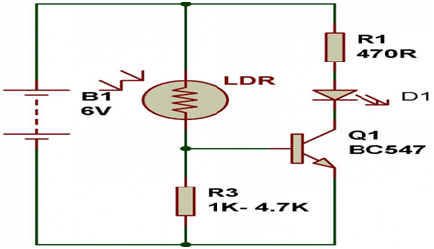

* **Photovoltaic Cells –**

Photovoltaic cells are energy conversion device used to convert solar radiation into electrical electric energy. It is used if we are planning to build a solar robot. Individually photovoltaic cells are considered as an energy source, an implementation combined with capacitors and transistors can convert this into a sensor.

Consider the circuit diagram of photovoltaic cell is,

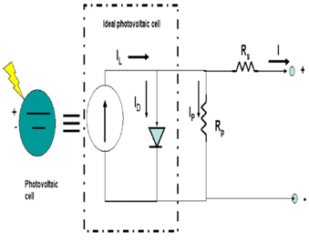

**Code:**

package robotwithlightsensor;

import ch.aplu.robotsim.*;

public class RobotWithLighSensor {

static {

RobotContext.setStartDirection(90);

RobotContext.setStartPosition(250, 10);

RobotContext.useBackground("sprites/black_white.gif");

}

// Making gear global to be used in handlers

private Gear gear = new Gear();

// initiate a legorobot with lighsensor and gear

public RobotWithLighSensor() {

LegoRobot robot = new LegoRobot();

LightSensor ls = new LightSensor(SensorPort.S3);

robot.addPart(gear);

robot.addPart(ls);

gear.forward();

while (true) {

if (ls.getValue() > 500) {

gear.leftArc(0.1);

} else {

gear.rightArc(0.1);

}

}

}

public static void main(String[] args) {

new RobotWithLighSensor();

}

}

**Output:**



**Conclusion:**

We successfully made use of light sensor to make a Lego robot follow a line/path.